Base

Definition
# Source: AI Source: Provided by: [Data Path: Persons Table -> ID Column: 1, Name_En Column: Motasem Essam] -> From: [ChatGPT] on [7/20/2026]
In geometry, a base is a designated side or face of a geometric figure that is used as a reference for measuring or calculating other geometric properties, especially height, area, and volume.
In simple terms:
The base is the side or face chosen as the reference surface from which a perpendicular height is measured.
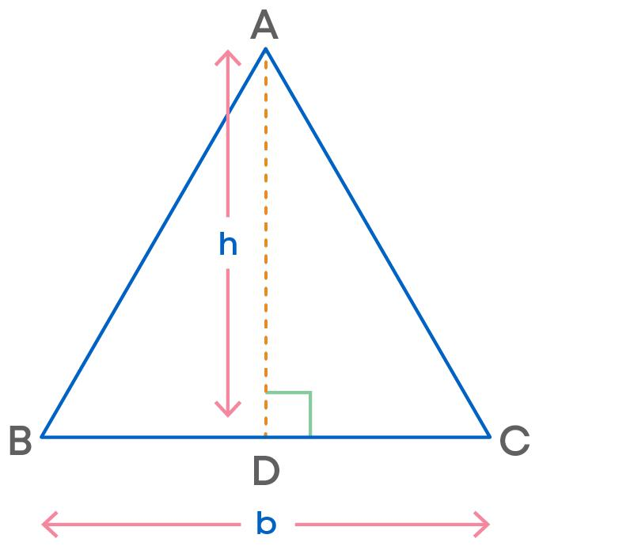
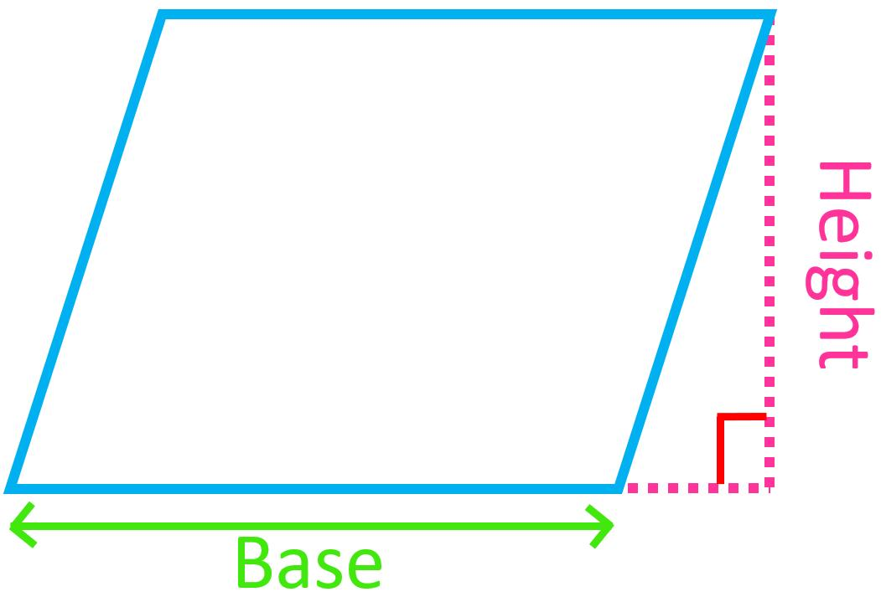
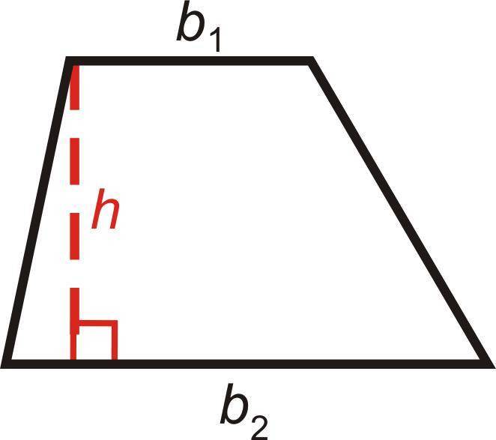
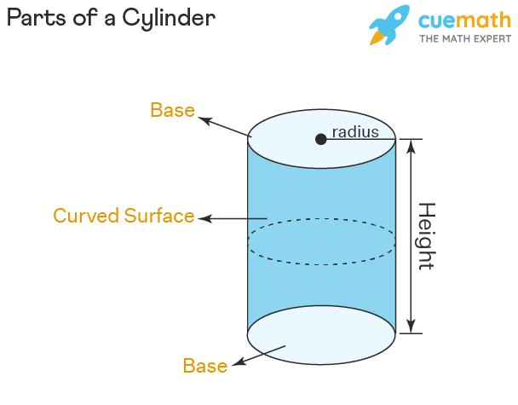

Base in Plane Geometry
# Source: AI Source: Provided by: [Data Path: Persons Table -> ID Column: 1, Name_En Column: Motasem Essam] -> From: [ChatGPT] on [7/20/2026]
For a 2D figure, the base is usually a side.

Triangle
# Source: AI Source: Provided by: [Data Path: Persons Table -> ID Column: 1, Name_En Column: Motasem Essam] -> From: [ChatGPT] on [7/20/2026]
Any side of a triangle can be selected as the base.
$$\boxed{A=\frac{1}{2}bh}$$
where:
- $b$ = base
- $h$ = perpendicular height measured to that base

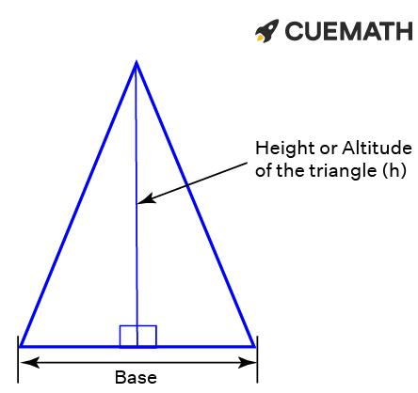
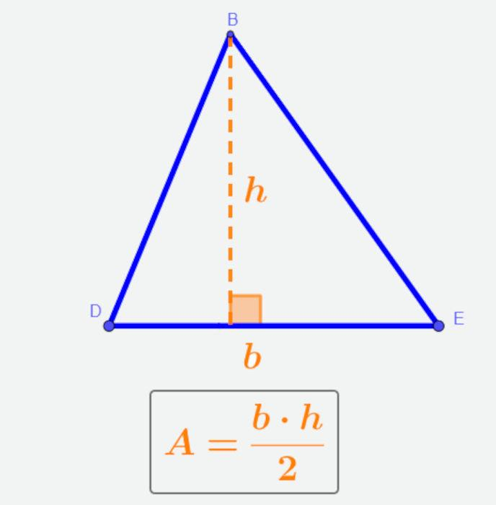
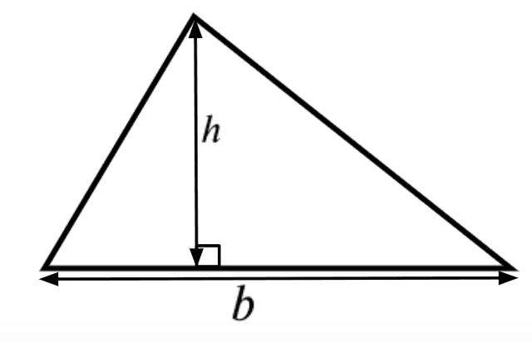

Parallelogram
# Source: AI Source: Provided by: [Data Path: Persons Table -> ID Column: 1, Name_En Column: Motasem Essam] -> From: [ChatGPT] on [7/20/2026]
The chosen side acts as the base, and the perpendicular distance to the opposite side is the height.
$$\boxed{A=bh}$$
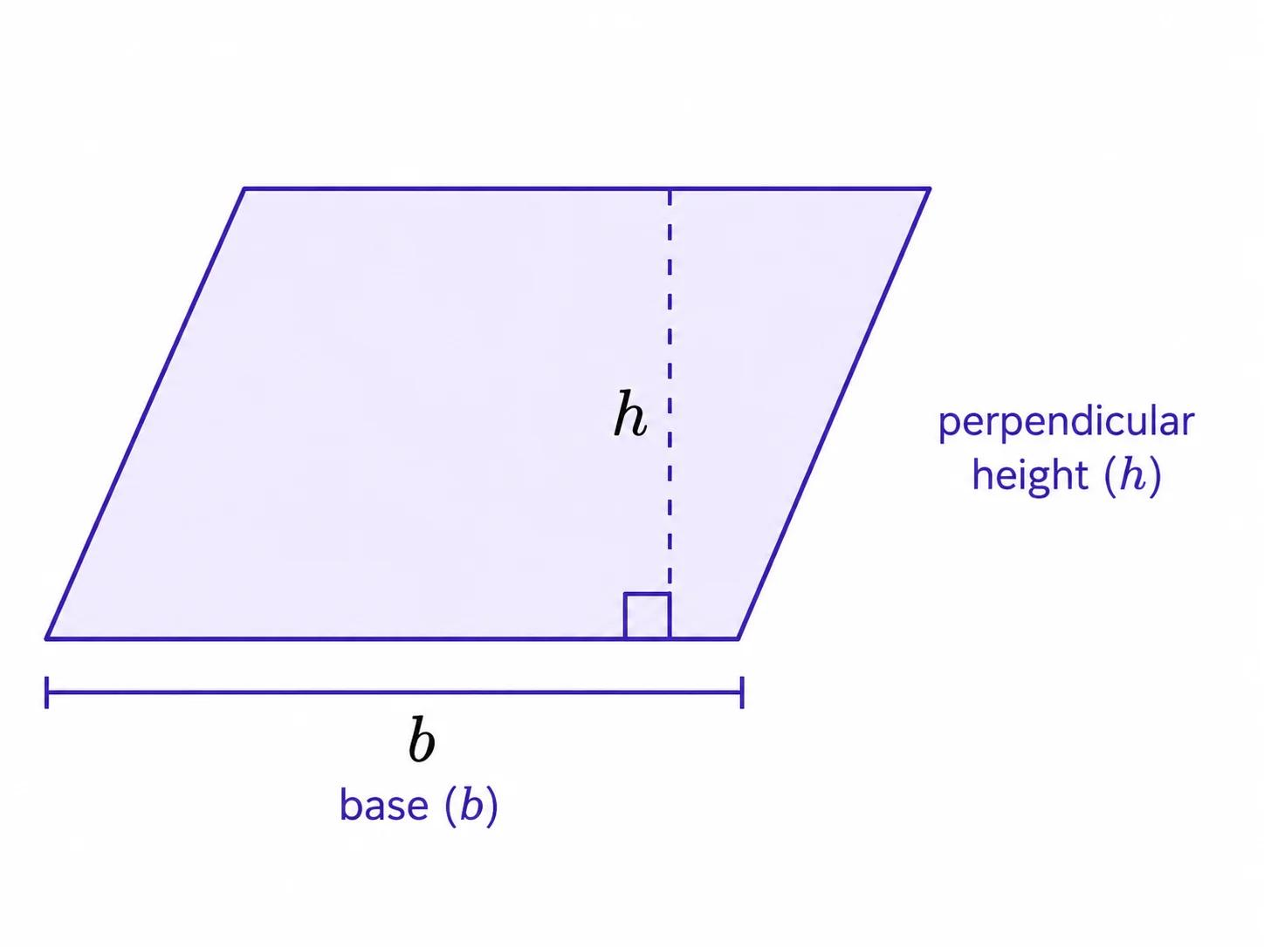
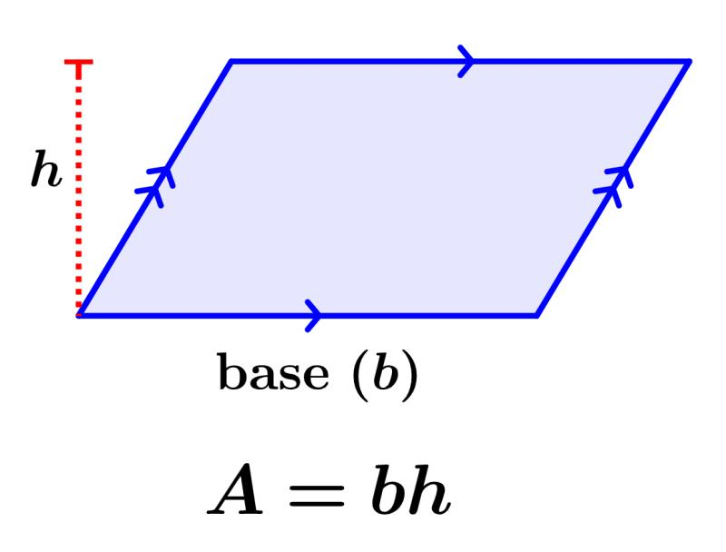
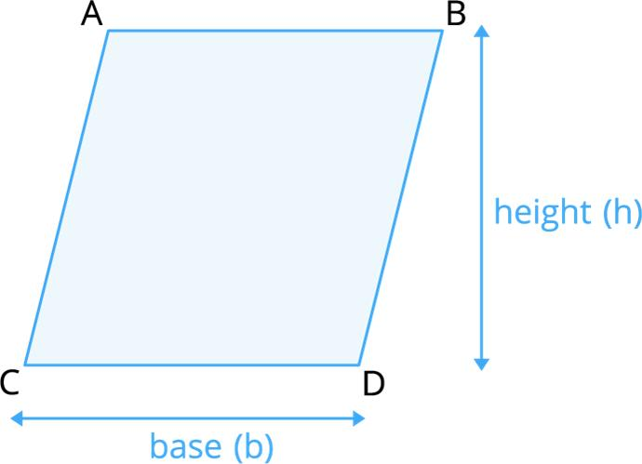
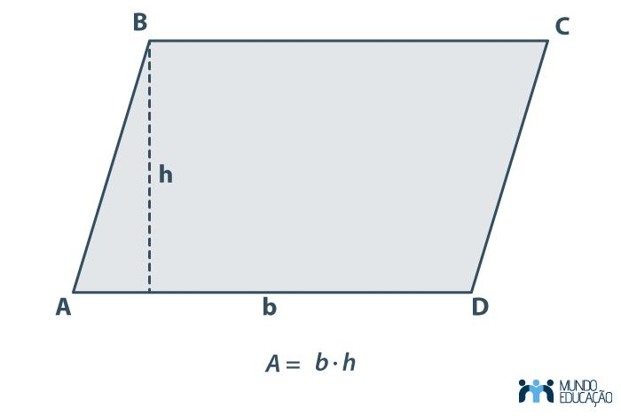
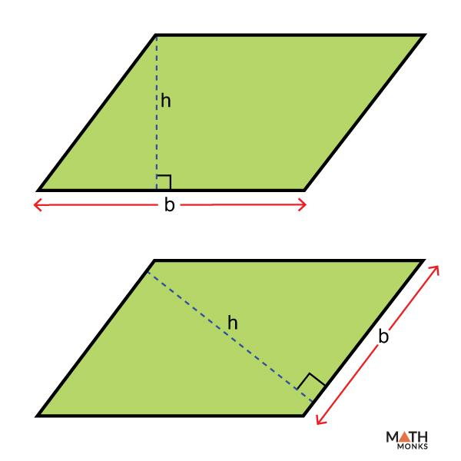

Trapezoid
# Source: AI Source: Provided by: [Data Path: Persons Table -> ID Column: 1, Name_En Column: Motasem Essam] -> From: [ChatGPT] on [7/20/2026]
A trapezoid has two bases, conventionally called $b_{1}$ and $b_{2}$.
$$\boxed{A=\frac{\left(b_{1}+b_{2}\right)h}{2}}$$

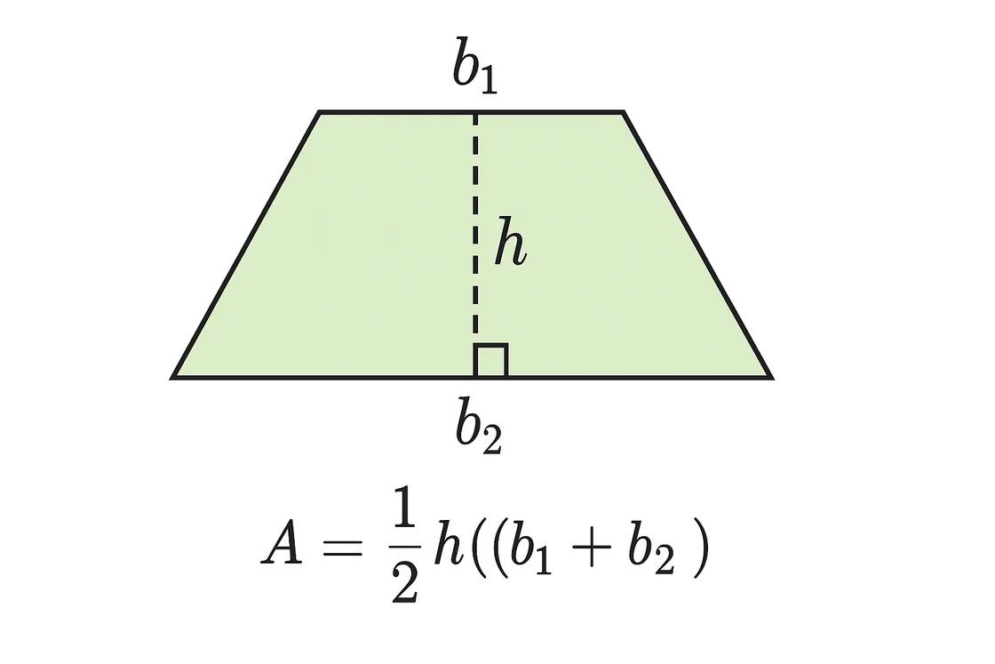
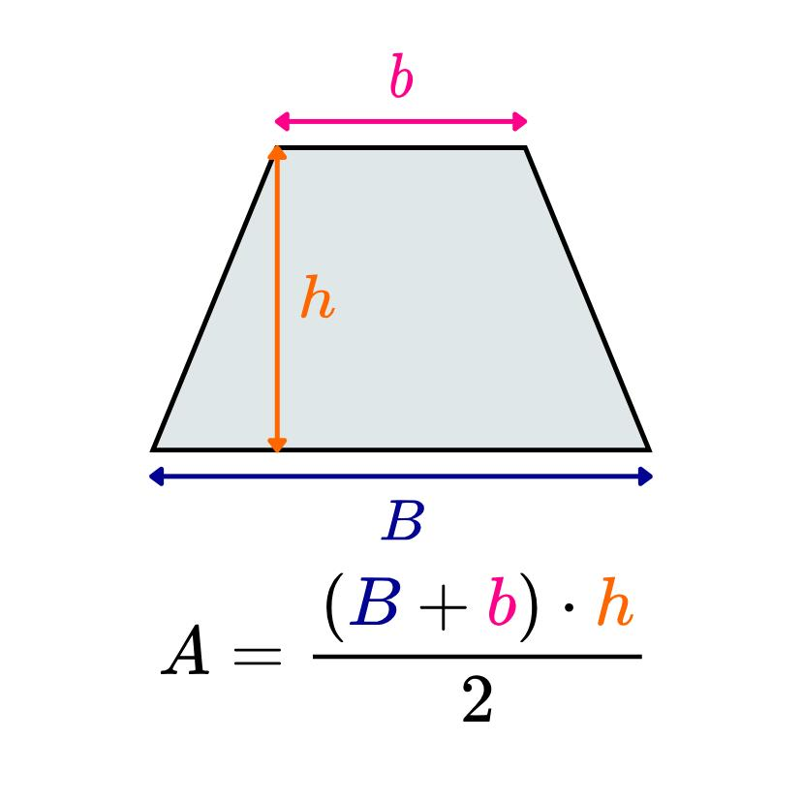
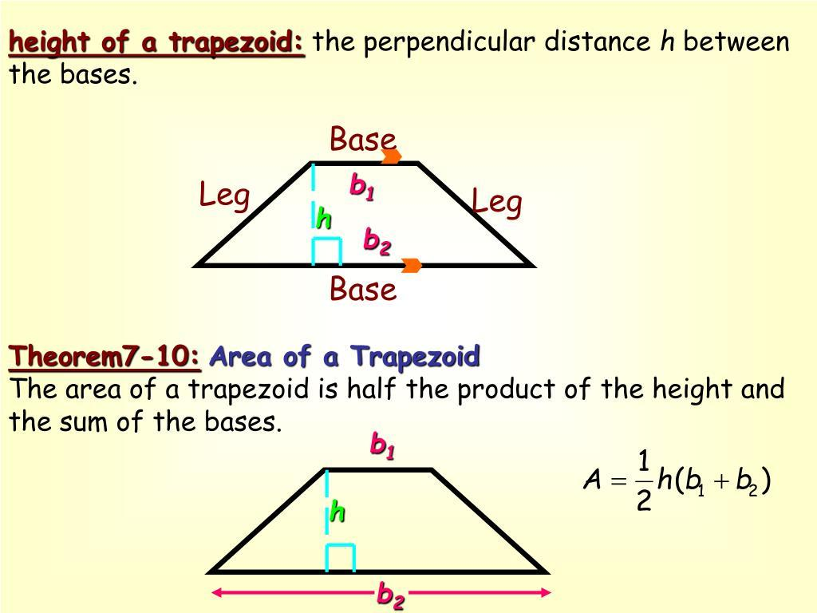

Base in Solid Geometry
# Source: AI Source: Provided by: [Data Path: Persons Table -> ID Column: 1, Name_En Column: Motasem Essam] -> From: [ChatGPT] on [7/20/2026]
For a 3D figure, the base is generally a face or cross-sectional surface used as the reference for measuring height or calculating volume.

Cylinder
# Source: AI Source: Provided by: [Data Path: Persons Table -> ID Column: 1, Name_En Column: Motasem Essam] -> From: [ChatGPT] on [7/20/2026]
A cylinder has two congruent circular bases.
$$\boxed{V=Bh}$$
For a circular base:
$$B=πr^{2}$$
so:
$$\boxed{V=πr^{2}h}$$
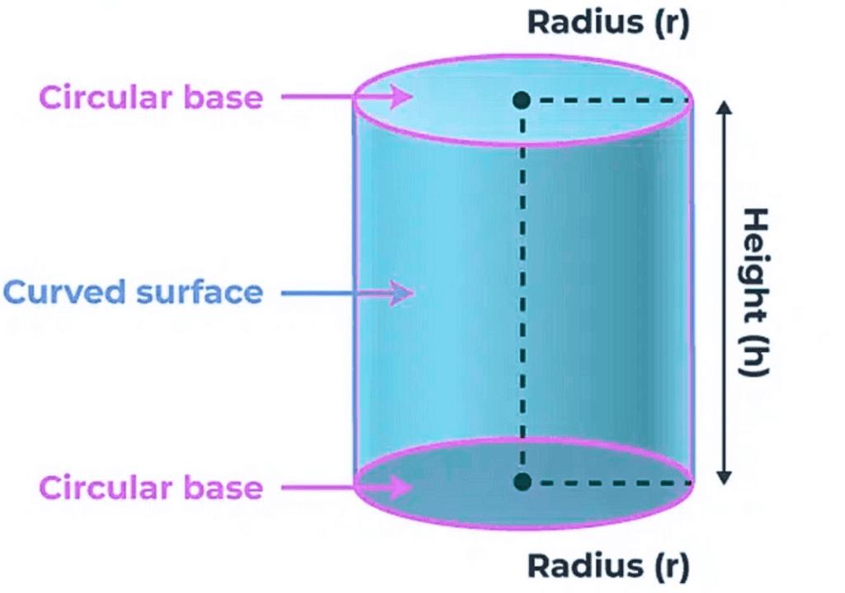

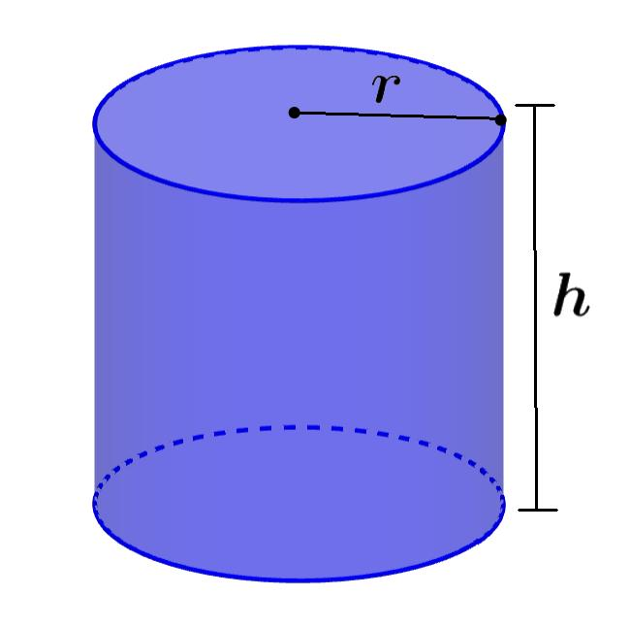
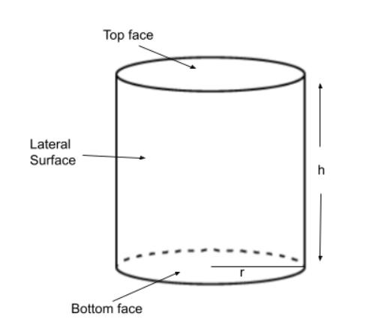

Prism
# Source: AI Source: Provided by: [Data Path: Persons Table -> ID Column: 1, Name_En Column: Motasem Essam] -> From: [ChatGPT] on [7/20/2026]
A prism has two congruent, parallel bases.
$$\boxed{V=Bh}$$
where $B$ is the area of the base.
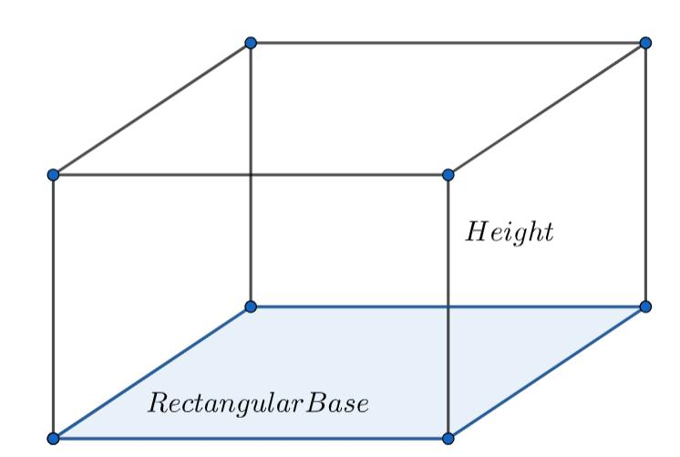
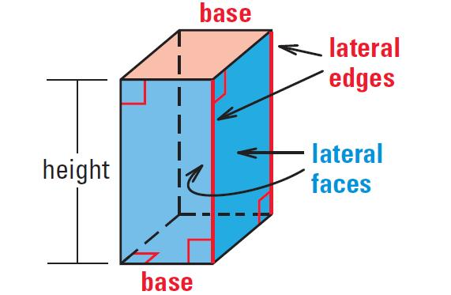
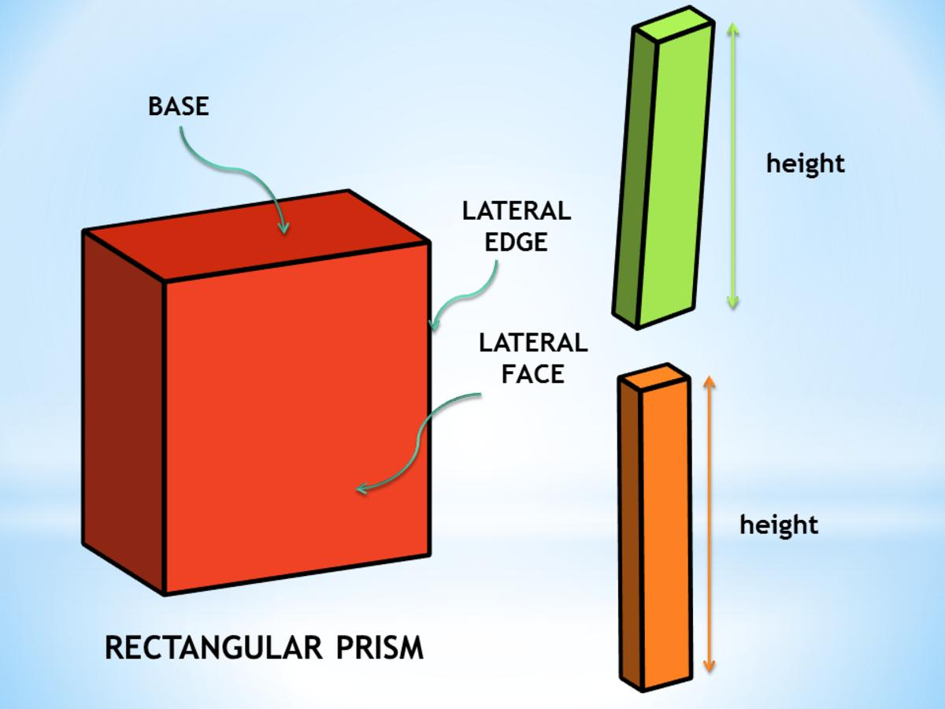
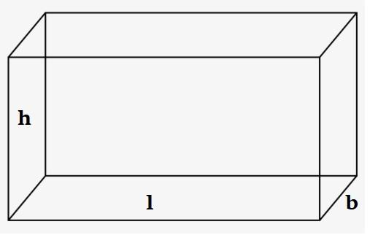
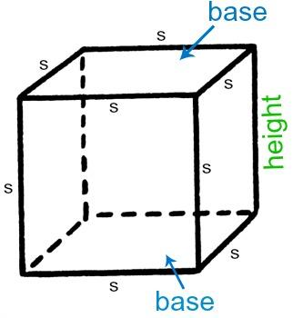
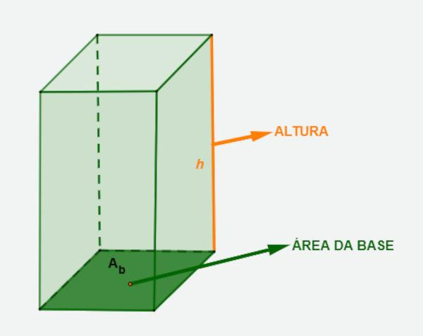

Pyramid
# Source: AI Source: Provided by: [Data Path: Persons Table -> ID Column: 1, Name_En Column: Motasem Essam] -> From: [ChatGPT] on [7/20/2026]
A pyramid has one base and a vertex (apex) that is not in the base plane.
$$\boxed{V=\frac{1}{3}Bh}$$
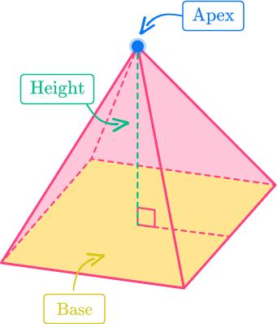
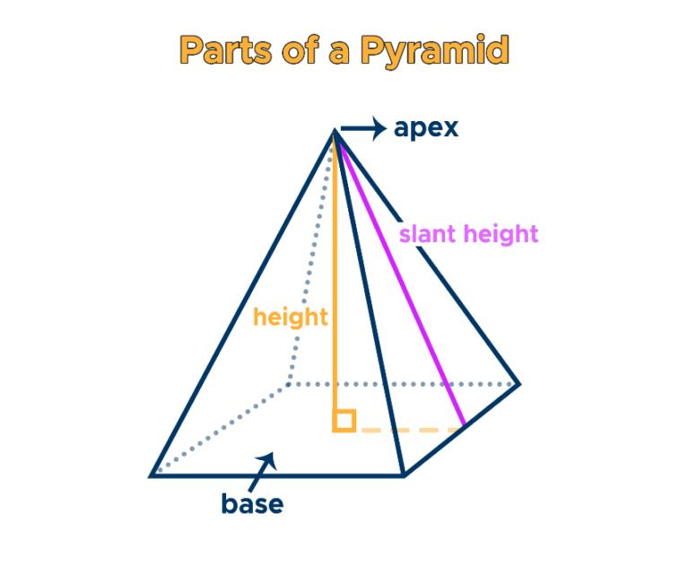
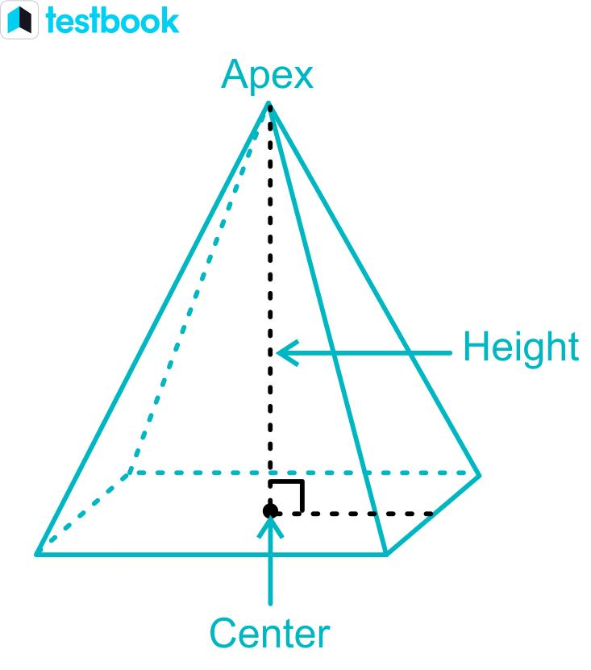
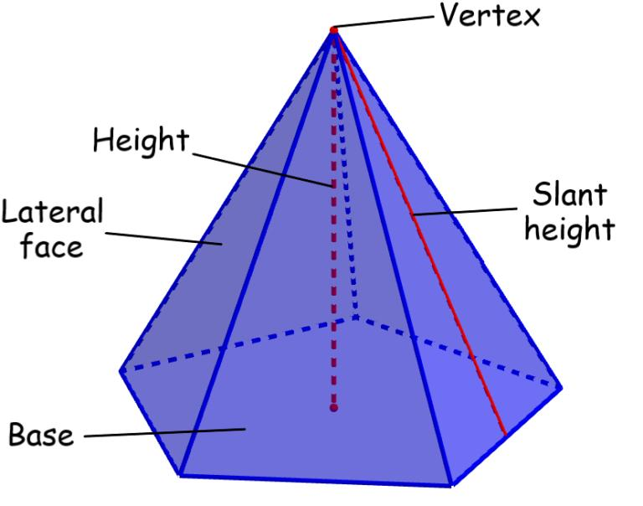
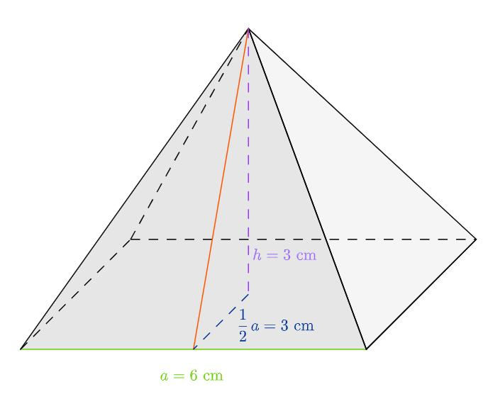

Cone
# Source: AI Source: Provided by: [Data Path: Persons Table -> ID Column: 1, Name_En Column: Motasem Essam] -> From: [ChatGPT] on [7/20/2026]
A cone has a circular base and an apex.
$$\boxed{V=\frac{1}{3}Bh}$$
For a circular base:
$$B=πr^{2}$$
therefore:
$$\boxed{V=\frac{1}{3}πr^{2}h}$$
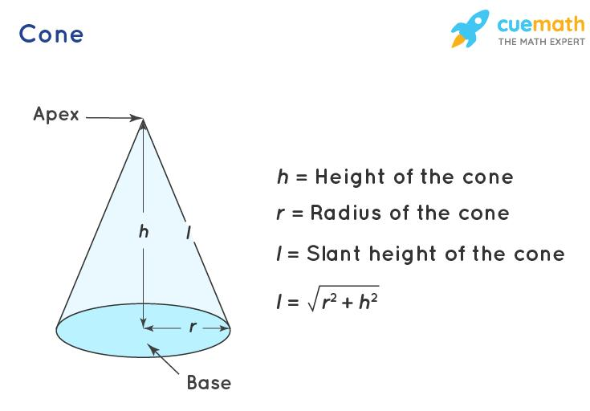
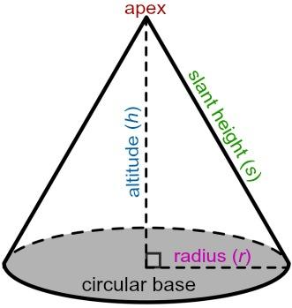
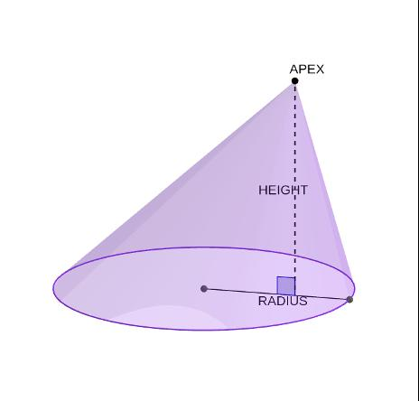
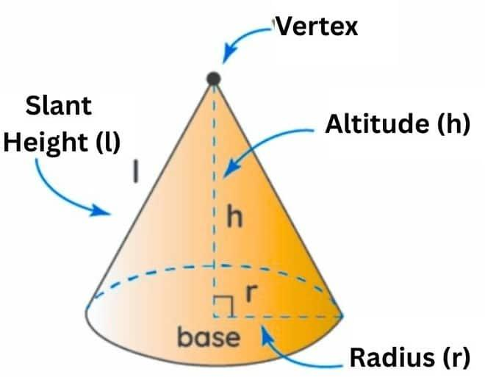
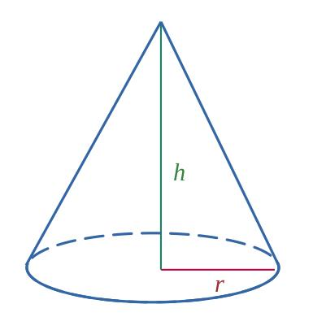

Base and Height
# Source: AI Source: Provided by: [Data Path: Persons Table -> ID Column: 1, Name_En Column: Motasem Essam] -> From: [ChatGPT] on [7/20/2026]
The height associated with a base is normally measured perpendicular to the base.
This distinction is important:
$$\boxed{\text{Height}⊥\text{Base}}$$
The height is not necessarily the slanted side of a figure.
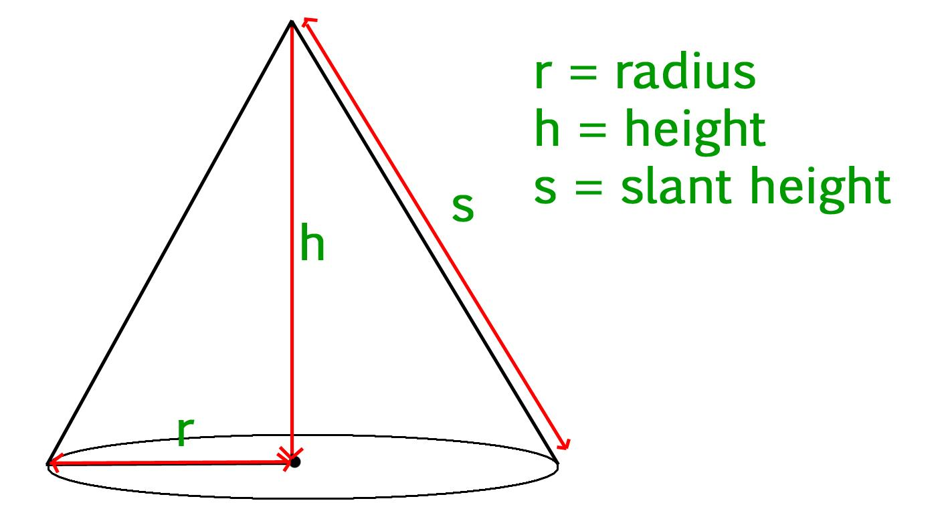

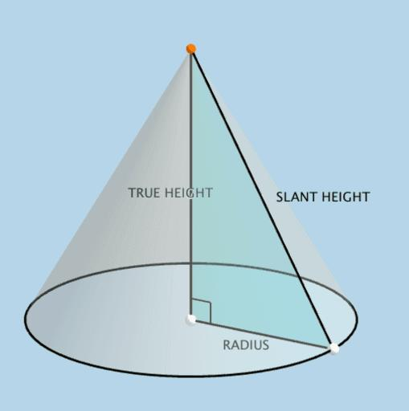
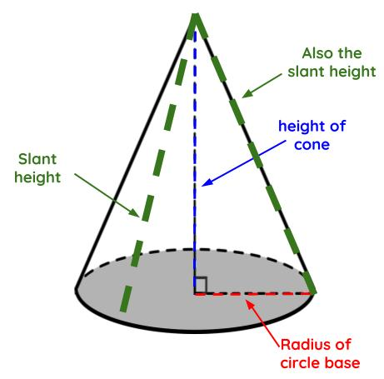
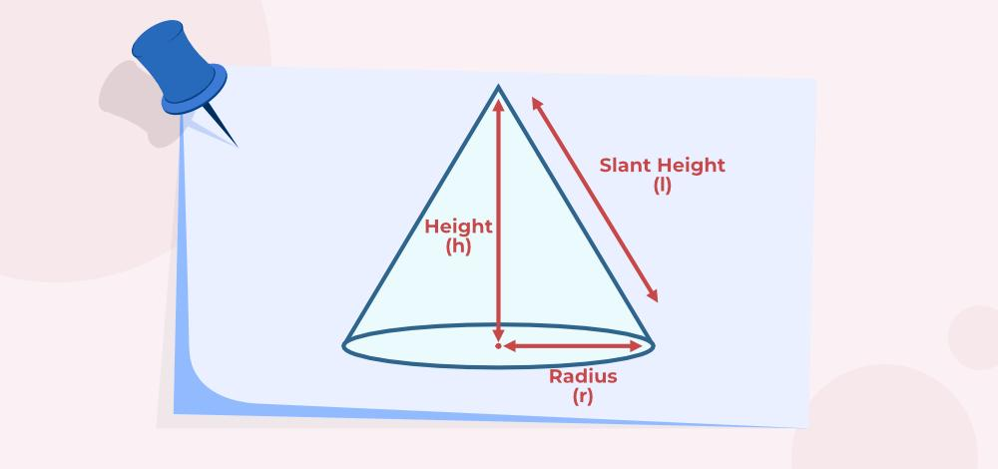

Important Property
# Source: AI Source: Provided by: [Data Path: Persons Table -> ID Column: 1, Name_En Column: Motasem Essam] -> From: [ChatGPT] on [7/20/2026]
A base is often not uniquely determined by the shape.
For example, in a triangle:
$$\boxed{\text{Any side can be chosen as the base}}$$
Changing the chosen base changes the corresponding perpendicular height, but the calculated area remains the same.

Base vs. Other Geometric Terms
# Source: AI Source: Provided by: [Data Path: Persons Table -> ID Column: 1, Name_En Column: Motasem Essam] -> From: [ChatGPT] on [7/20/2026]
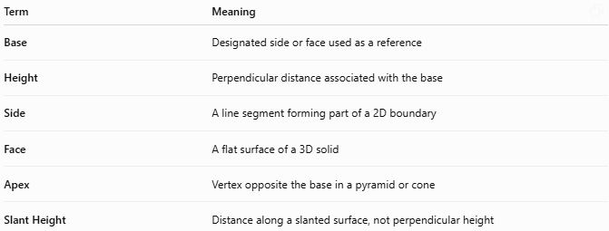
Term | Meaning
Base | Designated side or face used as a reference
Height | Perpendicular distance associated with the base
Side | A line segment forming part of a 2D boundary
Face | A flat surface of a 3D solid
Apex | Vertex opposite the base in a pyramid or cone
Slant Height | Distance along a slanted surface, not perpendicular height

Applications
# Source: AI Source: Provided by: [Data Path: Persons Table -> ID Column: 1, Name_En Column: Motasem Essam] -> From: [ChatGPT] on [7/20/2026]
Base is important in:
- Geometry
- Measurement Theory
- Engineering
- Architecture
- Technical Drawing
- Construction
- Manufacturing
- Mechanical Design
- CAD (Computer-Aided Design)
- Structural Design
- Surveying
- 3D Modeling

Advantages
# Source: AI Source: Provided by: [Data Path: Persons Table -> ID Column: 1, Name_En Column: Motasem Essam] -> From: [ChatGPT] on [7/20/2026]
Understanding the base helps to:
- Define a reference side or face of a geometric figure.
- Determine the corresponding perpendicular height.
- Calculate areas of triangles, parallelograms, and trapezoids.
- Calculate volumes of prisms, cylinders, pyramids, and cones.
- Establish a reference surface for geometric measurements.
- Support accurate geometric modeling and design.
- Analyze dimensions and spatial relationships.

Limitations
# Source: AI Source: Provided by: [Data Path: Persons Table -> ID Column: 1, Name_En Column: Motasem Essam] -> From: [ChatGPT] on [7/20/2026]
Base:
- Is not necessarily a unique side or face.
- May be chosen differently depending on the problem.
- Requires a corresponding height for many area and volume calculations.
- Does not by itself determine the complete size of a figure.
- Can change when the orientation or reference of a solid changes.
- Is different from the general concept of width or length.

Key Points
# Source: AI Source: Provided by: [Data Path: Persons Table -> ID Column: 1, Name_En Column: Motasem Essam] -> From: [ChatGPT] on [7/20/2026]
$$\boxed{\text{Base}=\text{Designated Reference Side or Face}}$$
The base:
- Can be a side in a plane figure.
- Can be a face in a solid.
- Is used to define the corresponding height.
- Usually has a perpendicular relationship with the height.
- Is fundamental to area and volume formulas.
- May be chosen differently depending on the problem.

Conclusion
# Source: AI Source: Provided by: [Data Path: Persons Table -> ID Column: 1, Name_En Column: Motasem Essam] -> From: [ChatGPT] on [7/20/2026]
A base is a designated side or face of a geometric figure that serves as a reference for measuring height, area, or volume. In plane geometry, the base is commonly a side of a triangle, parallelogram, or trapezoid. In solid geometry, it can be a face or cross-sectional surface, such as the circular base of a cylinder or cone or the polygonal base of a prism or pyramid. The corresponding height is measured perpendicular to the base, making the base–height relationship fundamental to many geometric calculations.

